Link
https://console.developers.google.com/flows/enableapi?apiid=calendar&pli=1
Step 2
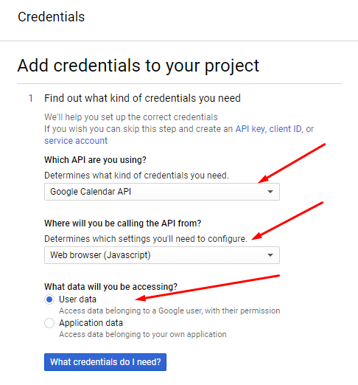

Step 3
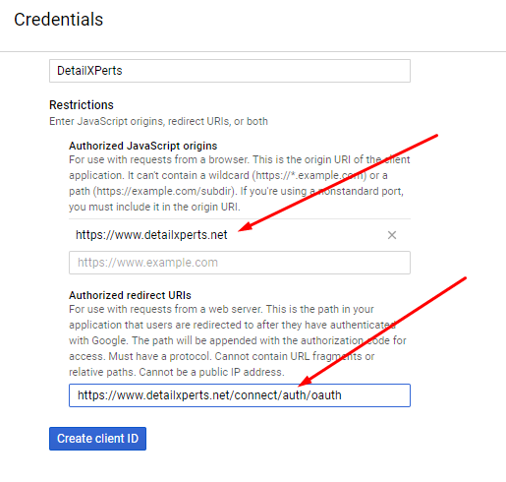

Step 4
